**Programming Competition 2025**

CASE STUDY FOR TERTIARY INSTITUTIONS

19 -28 SEPT 2025

**TITLE OF PROJECT: MEDICAL EXPERT SYSTEM FOR MALARIA AND TYPHOD FEVER (MESMTF)**

**FOR MINISTRY OF HEALTH AND SOCIAL SERVICES**

**GROUP MEMBERS:**

|  |  |  |  |
| --- | --- | --- | --- |
| **Sn** | **Name** | **Name of Institution** | **Role played in the project** |
| 1 | Josivaldo Ferreira Vissuma de Vasconcelos(TL) | International Training College Lingua | I was responsible for Developing the Back-End, supporting with the front end, and overall project coordination. |
| 2 | Joel Elisio Sabino de Carvalho | International Training College Lingua | I was responsible for Developing the Back-End, supporting with the front end |
| 3 | Rahman Shaquille Nyathi | International Training College Lingua | I was responsible for creating Front-End (coding pages) |
| 4 | Wilmer Gillandro Beukes | International Training College Lingua | I was responsible for creating Front-End (coding pages) |
| 5 | Raheem Kisting | International Training College Lingua | I was responsible for the designing for the user interfaces, also supported with creating Front-End (coding pages) and Documents |
| 6 | Brown Mbongo | International Training College Lingua | I was responsible for Developing the Back-End |

**DATE OF SUBMMISION: 26 SEPT 2025**

**Table of Contents**

1. **Description of Project....................................................................................................... 2**
2. **Functionalities Provided by the Software................................................................................ 3**
3. **Flowcharts and Algorithms................................................................................................. 5**
4. **Programming Languages/Tools Used...................................................................................... 7**
5. **Solution Architecture......................................................................................................... 8**
6. **Sample Source Code Snippets............................................................................................ 10**
7. **Sample Solution/Software Screenshots................................................................................. 12**
8. **Conclusion...................................................................................................................... 14**
9. **Description of Project**

The **Medical Expert System for Malaria and Typhoid Fever (MESMTF)** is a web-based solution designed for the Ministry of Health and Social Services. The system provides intelligent e-Health services by combining medical record management to aid in the diagnosis, treatment and follow-up of patients.

The MESMTF allows patients to register, book doctor appointments, and securely manage their medical records online. Doctors and healthcare staff benefit from tools that streamline diagnosis, prescription management, pharmacy integration, drug administration, and reporting.

The purpose of the MESMTF is to improve healthcare delivery, reduce delays in diagnosis, and provide patients with convenient access to medical services both online and offline. Ultimately, the system benefits patients, doctors, pharmacists, and the Ministry of Health by increasing efficiency, enhancing decision-making, and ensuring better patient outcomes.

1. **Functionalities Provided by the Software**

The Medical Expert System for Malaria and Typhoid Fever (MESMTF) provides a comprehensive set of healthcare-related functionalities. These functionalities are designed to serve patients, doctors, pharmacists, administrators, and other healthcare staff in an integrated platform.

**Functions**

**User Registration & Authentication**

* Patients, doctors, pharmacists, and administrators can register and log in securely using unique credentials.
* Role-based access ensures that each user sees only the features relevant to their role (only admin can change roles).

**Key Functionalities Based on User Dashboards**

**Example of how the dashboards look**

|  |
| --- |
|  |

**1. Patient Dashboard**

* Prescriptions: View and download prescribed medications.
* Medical Records: Access and upload personal health records securely.
* Calendar: Track and note upcoming appointments.
* Appointments: Book doctors’ appointments.
* Messages: Communicate with doctors, pharmacists, or admins.
* Log Out: Securely exit the system.

**2. Admin Dashboard**

* User Management: Add, update, or remove users (patients, doctors, pharmacists, etc.) and assign roles.
* Reporting & Analytics: Generate system-wide reports on usage, patient trends, and healthcare statistics.
* Messages: Communicate with users regarding system or account-related issues.
* Log Out: Secure session termination.

**3. Doctor Dashboard**

* Reporting & Analytics: Access reports related to diagnosis, treatments, and patient data trends.
* Diagnosis & Treatment: Perform patient diagnosis using expert system rules and prescribe treatments.
* Appointments: Manage scheduled patient consultations.
* Patient Management: View patient profiles, medical history, and diagnosis records.
* Calendar: Track and note upcoming appointments.
* Log Out: Securely end session.

**4. Pharmacist Dashboard**

* Prescriptions: Review and validate prescriptions from doctors.
* Pharmacy Operations: Manage pharmacy inventory, stock levels, and drug availability.
* Drug/Medication Management: Dispense medications, update records of administered drugs.
* Messages: Communicate with patients or doctors regarding prescriptions.
* Calendar: Track and add notes.
* Log Out: End secure session.

1. **Flowcharts and Algorithms**

**The Flowcharts were created on the website:www.smartdraw.com**

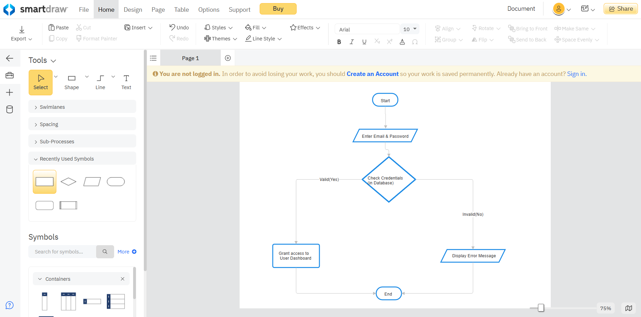

**1. Login**

BEGIN

INPUT username, password

IF username AND password match records in database THEN

DISPLAY dashboard based on user role

ELSE

DISPLAY "Invalid login credentials"

ENDIF

END

|  |
| --- |
|  |

BEGIN

Patient selects "Book Appointment"

DISPLAY list of available doctors and time slots

Patient chooses doctor and time

IF selected slot is available THEN

SAVE appointment in database

NOTIFY doctor

DISPLAY "Appointment confirmed"

ELSE

DISPLAY "Slot unavailable, please choose another"

ENDIF

ENDEND

**2. Appointment Booking Process(Paitient)**

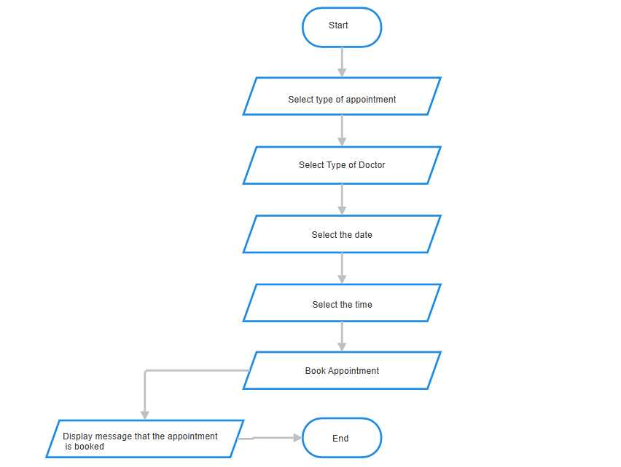

1. **Programming Languages/Tools Used**

**Front-End Development**

* HTML: For structuring the web pages.
* CSS: For styling and creating a responsive, mobile-friendly user interface.
* JavaScript: For dynamic client-side interactions and form validations.

**Back-End Development**

* PHP: Server-side scripting language for handling business logic and database interactions.

**Database Management**

* MySQL: Relational database management system for storing user data, medical records, appointments, and drug information.

**Design & Modeling Tools**

* SmartDraw: For creating professional flowcharts and system diagrams.
* Adobe XD: For designing user interface prototypes and mockups.

**Development & Deployment Tools**

* XAMPP: Local server environment for development and testing.
* Git & GitHub: For version control and collaborative development.
* Google Drive: For project backup and submission.

|  |  |  |
| --- | --- | --- |
| **Type/Development** | **Programming Language** | **Tools** |
| Front-End | 1.HTML  2.CSS  3.JavaScript | 1. Visual Studio  2.Adobe Dreamweaver |
| Back-End | 1.PHP |  |
| Database Management |  | 1.MySQL |
| Design & Modelling Tools |  | 1.Adobe XS  2. SmartDraw |
| Development & Deployment |  | 1.XAMPP  2.Git & GitHub  3.Google Drive |

**Simplified in a Table**

1. **Solution Architecture**

**Presentation Tier (Front-End):**

|  |  |  |
| --- | --- | --- |
|  |  |  |

This is the user interface layer built with HTML, CSS, and JavaScript.

It runs in the client's web browser and is responsible for displaying information and capturing user input.

It communicates with the Logic Tier via HTTP requests to send and receive data.

**Application/Logic Tier (Back-End):**

|  |  |  |
| --- | --- | --- |
|  |  |  |

This tier contains the core application logic, implemented in PHP.

It processes requests from the Presentation Tier, handles business logic (e.g. booking appointments), and interacts with the Data Tier.

It acts as the intermediary, ensuring data is validated and processed correctly before being stored or presented.

**Data Tier (Database):**

|  |  |  |
| --- | --- | --- |
|  |  |  |

This tier consists of the MySQL database server.

It is responsible for the persistent storage of all data, including user profiles, medical records, appointment schedules, drug inventories, and diagnosis history.

The back-end scripts in the Logic Tier use SQL queries to Create, Read, Update, and Delete (CRUD) data in this tier.

**This architecture ensures security (as database credentials are not exposed to the client), improves performance, and makes the system easier to update and manage.**

1. **Sample Source Code Snippets**

**Patient Dashboard**

**Presentation Tier (Front-End)**

**Key Features & Best Practices Used**

Semantic HTML: Proper use of form elements and labels

Accessibility: ARIA attributes and proper labelling

Security: Password field masking

Validation: Required fields and email format validation

Responsive-ready: Viewport meta tag included

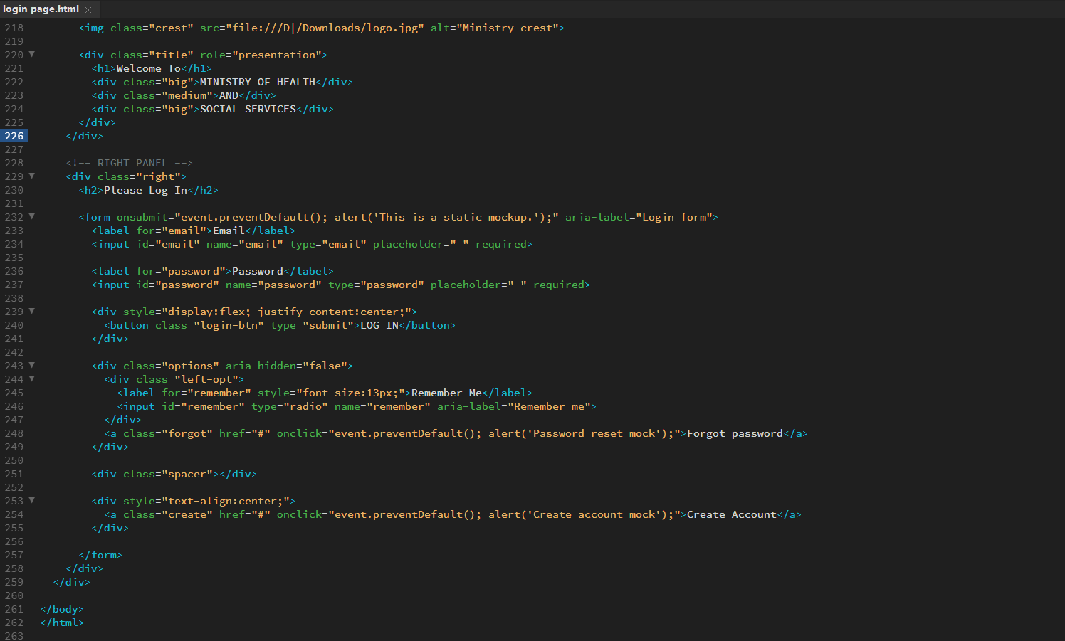

**Application/Logic Tier (Back-End)**

**Key Features Implemented:**

1. Patient Listing: Displays all patients in the system
2. Search Functionality: Find patients by name or ID
3. Pagination: Handles large datasets efficiently
4. Security: Uses prepared statements to prevent SQL injection
5. Performance: Limits results and uses efficient queries

Database Schema Insight:

The code reveals the patients table structure:

* id - Primary key
* first_name, last_name - Patient names
* gender - Gender information
* date_of_birth - Birth date
* contact_phone - Phone number
* external_identifier - Possibly hospital ID or national ID

|  |
| --- |
|  |

**Data Tier (Database):**

**How This Table Integrates with MESMTF System**

**Role-Based Access Control:**

**This users table enables the different dashboards you showed earlier:**

* Patients (role_id = Patient): See only their medical records and appointments
* Doctors (role_id = Doctor): Access diagnosis, treatment, and patient management
* Admins (role_id = Admin): Full system access including user management
* Pharmacists (role_id = Pharmacist): Pharmacy and prescription management

|  |
| --- |
|  |

1. **Sample Solution/Software Screenshots**

|  |
| --- |
|  |

**Figure 1: User Login Page**

This is the entry point to the MESMTF system. Users can log in with their credentials or navigate to the account creation page.

|  |
| --- |
|  |

**Figure 2: Patient Dashboard**

The Patient Dashboard provides centralized access to all patient-specific functionalities, including Prescriptions, Medical Records, Appointments, and Calander.

**Figure 3: Booking Appointment (Patient)**

The Patient Dashboard provides centralized access to all patient-specific functionalities, including Prescriptions, Medical Records, Appointments, and Calander.

|  |
| --- |
|  |

**Figure 4: Patient Appointment Booking Workflow**

This figure illustrates the seamless, step-by-step process a patient follows to book a medical appointment.

A. Dashboard Initiation: The patient navigates to the "Appointments" section from their main dashboard, which also provides an overview of any upcoming or past appointments.

B. Booking Interface: The patient is presented with an intuitive booking form. Key features include:

Select Doctor: A menu of available doctors, filterable by specialization.

Select Date & Time: A dynamic calendar and time-slot selector that updates based on the chosen doctor's availability.

Reason for Visit: A field for describing symptoms, which can be pre-populated if the patient is referred from the AI-Doctor diagnosis module.

The patient finalizes the booking by clicking the "Book Appointment" button.

C. Booking Confirmation: Upon successful submission, the system displays a clear confirmation message. This screen summarizes the appointment details (Doctor, Date, Time, Appointment ID)

1. **Conclusion**

The project was a success in motivating our team to collaborate, innovate, and push ourselves to create a working solution. Although still at a developmental stage, the system demonstrates its potential and can be further enhanced to become an important tool for advancing digital health services in Namibia.

Throughout the process, we also recognized areas where improvement is needed. Our initial excitement led us to begin quickly without adequate preparation. This taught us the importance of proper planning, guidance, and technical support from mentors who can provide both instructions and hands-on assistance. Additionally, we realized the need to deepen our knowledge in critical areas such as APIs, machine learning, and expert systems to strengthen the functionality and intelligence of the platform.

Looking ahead, there are many opportunities to improve the system further. Enhancements can be made to modules, database efficiency, and overall user experience to ensure smooth operation. A fully integrated messaging system between administrators, doctors, pharmacists, and patients would also add significant value by improving communication and collaboration within the system.

----------------------------------------------THE END-------------------------------------------------